Step It Up for Gender Equality in
South African Media
Background:
Gender-based violence (GBV) remains one of the biggest challenges and obstacles to development in South Africa, with rape, domestic violence and intimate-partner violence particularly prevalent. An average of 100 rapes are recorded daily and this does not account for unreported incidents. According to South Africa’s 2016 Demographic and Health Survey one in five women over the age of 18 has experienced physical violence at least once in her lifetime. The rate of femicide in South Africa is four times that of the global average, meaning everyday three women die at the hands of their intimate partners. The crisis of GBV and femicide in South Africa is well documented and reflects a society that is saturated in patriarchy, unequal gender dynamics and daily gross human rights violations against women and children.
In late 2017 the German Development Cooperation (GIZ) in South Africa, started a regional programme focused on prevention, the ‘Partnerships for Prevention of Violence against Women and Girls in Southern Africa Programme’ (PfP). The main objective of the PfP programme is to strengthen multi-stakeholder approaches that join governmental, civil society, academia and private sector efforts to prevent violence against women and girls. Prevention interventions challenge the deeply rooted inequalities and social norms that perpetuate men’s control and power over women and reinforce tolerance for violence against women and girls. Harmful social norms and stereotypes play a crucial role in perpetuating the current GBV crisis in South Africa. Violence emanates from deeply rooted biases, norms and stereotypes that cause structural psycho-social unequal gender dynamics. Media and the creative industries remain a stronghold of shaping norms and stereotypes through storytelling, images and audio-visual representations of men, women and gender non-conforming people. A preventative approach therefore needs to value media and entertainment as a key gate keeper for sustainable change to structural causes of violence and inequality.
It is against this background that the PfP and UN Women South Africa jointly started the Step it Up for Gender Equality in South African Media project. A report by Media Monitoring Africa conducted for the PfP programme in 2018 suggested that in the South African media and entertainment sector “there does not appear to be a coordinated approach or a single initiative that addresses sensitive programming and challenges with gender stereotyping in the creative industries.” This informed the conceptualization of the Step It Up project. The project’s main aim is to create a platform for the media and entertainment industry to self-examine, explore and reconstruct their role in shaping societies’ norms and stereotypes around gender, equality and gender-based violence. It supports this behaviour change of media organisations and jointly with government, civil society and industry formulates and promotes a voluntary ‘Statement of Commitment’ by the media and creative industries for a positive portrayal of gender relations and against gender violence. To reach these goals the Step It Up project works according to a number of key principles and activity fields.
Creating Multi-stakeholder Ownership:
In the inception of the project an Advisory Group was set up to inform, shape and guide the project activities and interventions. The Advisory Group consists of key stakeholders from government, civil society and private sector. While the managing secretariat is comprised of UN Women South Africa and GIZ-PfP, the Advisory Group includes key stakeholders such as the government Departments for Communication and Information Systems (GCIS), for Sports, Arts and Culture and for Communication, NGOs such as Gender Links, Sonke Gender Justice, Soul City Institute and Sisters Working In Film and Television (SWIFT), industry bodies such as the South African National Editors Forum, the South African Guild of Actors, the Writers' Guild of South Africa and the Kwa-Zulu Natal Film Commission, and broadcasters such as the public South African Broadcasting Corporation (SABC) and the private channels Moja Love, MultiChoice and Kaya FM. Further the Step It Up project has early on received advise and support from the German foundation MaLisa Stiftung which works on similar topics in the German media space. The connection to the MaLisa Stiftung has remained and informed some of the research project in South Africa.
Providing Evidence through Research:
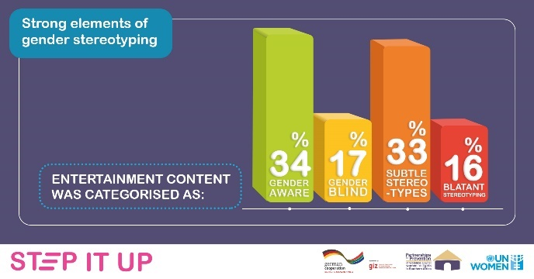
The Step it Up for Gender Equality in South African media project relies heavily on sound research to inform activities and interventions. To kick-start and facilitate a national, sector-wide dialogue the NGO Gender Links, a Southern African women’s rights organisation that promotes gender equality in and through media, undertook extensive research on current dynamics of gender representation, stereotyping and the portrayal of gender-based violence in South African television. The research, entitled ‘Gender, Diversity and GBV in South African Television’ aimed to: generate baseline information and raise public attention around the topic of diversity, the portrayal and reporting of gender-based violence and gender stereotyping in South African audio-visual media covering the South African public and private television stations. The research found that gender stereo-types are still prevalent, women’s voices are heard less and decision making still lies with men. Women for example compromise 77% of programme creators but just 15% of directors in entertainment. A concern from a prevention perspective is also the finding that in the breakdown of topic categories prevention constitutes only 5% of GBV topic coverage in the news and 29% in children’s programming.
The Step It Up project is currently conducting research that investigates the main factors that influence gender sensitivity and stereotyping in the production (work) environment in the media entertainment sector. Our assumption is that if media houses become aware of the barriers that prevent and factors that enable gender-sensitive and non-stereotyped storytelling for South African entertainment television, it is possible to introduce activities that reduce barriers and enhance enabling factors to contribute towards more gender-responsive media outputs in terms of content, access and participation.
Facilitating Sector-Wide Dialogue:
The Step It Up project has served as a platform for industry, government and civil society to begin a sector wide dialogue. The dialogue has centred around introspection, discussing challenges, best practice and solutions towards more sensitive reporting and portrayals of gender and violence. For the media and entertainment sector stakeholders it is the first time to have the opportunity to focus on their role and responsibility in the light of gender equality and gender-based violence. The project made it possible to jointly discuss possible concrete steps towards curbing harmful stereotypes and promoting positive portrayal of gender relationships.
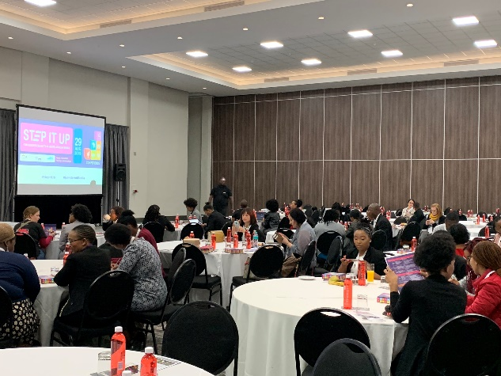
The meetings of the Advisory Group itself as well as several further activities of the project made this dialogue possible. During workshops with community radio stations in three South African provinces the project supported the stations to identify their particular needs when it comes to sensitive gender reporting, creating an enabling, sensitive and safe workplace environment and gender stereotypes in storytelling and talk shows. During the Durban International Film Festival in June 2019, the ‘Step it Up for Gender Equality in South African’ media project conducted a focus group discussion with producers, directors and writers to identify challenges in the industry relating to gender equality and more social change-driven storytelling. Following these consultations and many bi-lateral meetings stakeholders, the project organised the sector-wide Step it up for Gender Equality in South African Media Conference in August 2019. The conference centred around three main themes identified during previous consultations namely:
Step it Up for Gender Equality in South African Media Conference.
- Sensitive reporting on GBV in the news,
- The question of the balance between storytelling for social change and reflecting reality,
- And a safe and equal environment ‘behind the scenes’.
Impressions from the conference were captured in a video.
Building capacities:
Dialogue and reflection are needed but alone they will not be enough to lead to a real and impactful change of behaviour with in the media industries and within the people creating, editing and commissioning news and entertainment content. A further key principle of the Step It Up project is to support capacity building in the specific field of gender sensitivity. The media and entertainment industries of course have their own dynamics, structures and job descriptions. Approaches such as trainings therefore have to be adapted to the needs of the target group and differ within the news spaces and the creative production process. Looking to 2020 the project will deliver gender sensitivity trainings for community radio stations, the SABC’s radio and television stations, interested private broadcasters and production companies as well as government communicators.
In June 2019 the Step It Up project exposed South African producers, directors, writers and actors at the Durban International Film Festival to the Intimacy Directors Approach from the United Kingdom. The approach teaches a different more sensitive and safe way to direct and shoot intimate scenes. Bringing this approach to South Africa is part of a central understanding of the Step It Up project, that there is a direct connection between how women are treated within the industry and how sensitive and influential the outcome of the creative process can be to the final viewer. All activities such as research, dialogues and trainings address both aspects the impact of the produced content as well as the situation for women ‘behind the scenes’.
Promoting broad voluntary commitment:
In order to maintain sustainability, the ‘Step it Up for Gender Equality in South African media’ project together with the Advisory Group is developing a voluntary ‘Statement of Commitment’ for media and creative industry organisations to sign up to. The ‘Statement of Commitment’ could include commitments on: Sensitive reporting on GBV and portrayal of GBV in entertainment, increase in women and female sources in media, less blatant gender stereotypes in media, an equal and protective treatment of women working in the sector and an increase in women in all levels of management and decision-making. Commitments should be at the same time realistic and ambitious. The ‘Statement of Commitment’ will be launched publicly to promote more support and accountability through civil society and he public.
In line with the aim to promote voluntary commitment the Step It Up project also supported for the Durban International Film Festival to sign up to the “50/50 by 2020 Campaign” committing to gender parity in all its management, judging and award-giving structures by 2020. Through a study visit to the Berlinale Film Festival in Berlin in 2019 two colleagues of the NGO SWIFT were able to participate in several exchanges of international women’s organisations and ultimately bringing the campaign to South Africa and promoting it at the Durban film festival together with further Advisory Group members.
Key Challenges:
- A challenge has been getting the full buy-in of large private sector companies. Private sector companies have shown interest in the project and voiced support but are still reluctant to sign-up to the full project and the idea of voluntary commitment. Exceptions have been smaller production houses and talk radio stations such as Siyaya T.V, talk radio 702 and Kaya fm. Importantly the project also recently received support from the very popular and controversial private reality TV channel Moja Love. It is also important to say that in South Africa private broadcasters have a far smaller reach than the TV and radio stations of the public broadcaster SABC and community radio stations.
- Another challenge has been getting men from the various media houses actively involved in the project. The majority of active participants in the project are women with very few exceptions.
Key Successes:
- The uptake of the research has been incredibly positive. The research was publicly launched at a Mail and Guardian Critical Thinking Forum in May 2019 and received media coverage. Partners have been frequently asking for and quoting the research. The Step it Up for Gender Equality in South Africa media project and partners on the Advisory Group have presented the research numerous times including at the GCIS ‘Women in Media’ dialogue and the Africa Radio Days Conference.
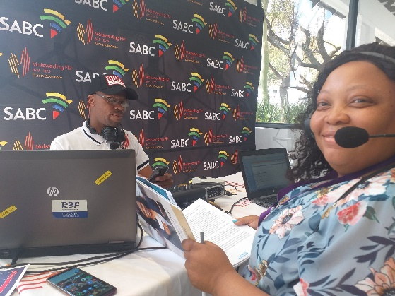
- Jointly with the Department of Sports, Arts and Culture the Step It Up project financed the NGO SWIFT to develop and pilot an approach promoting safety for women on film and television sets. The ‘Safety Contact’ project describes the idea of a Person, who, in the absence HR capacity in most production companies, would educate staff around their rights and ensure that safety measures in respect to harassment and exploitation are met on set. This follows SWIFT research that showed that more than 70% of women do not feel safe on set.
- The partnership model has worked effectively. All activities implemented in the project, from research to capacity building have been implemented jointly with partners. The interest in the project and such partnerships have made the Advisory Group include new members.
- The ‘Step it Up for Gender Equality in South African Media Conference’ was well attended and widely publicized. 16 radio stations broadcasted about the conference, with two broadcasting live from the event.
Joan Moeketsi, GIZ Component Manager SA: Partnerships for Prevention of Violence against Women and Girls in Southern Africa (PfP) being interviewed on SA fm.

Evaluating Impact
On the one hand the support from media and entertainment sector organisations and companies for the ‘Statement of Commitment’ will serve as a central measurement of impact and also as a key tool for sustainability after the project term. Since the signing up is voluntary, the number of media outlets, creative industry companies, civil society institutions, industry bodies and government departments that sign up will demonstrate the impact of the project on partners. On the other hand the Step It Up project consciously created the ideal baseline through the commissioned media monitoring research by the NGO Gender Links ‘Gender, Diversity and GBV in South African Television’ which monitored 600 hours of television programming across five South African public and private television stations. It is envisioned that the monitoring exercise will be repeated and ultimately also become part of Gender Links’ periodic review of the South African media space. Based on changes in the findings the impact of the activities of the Step It Up project can be evaluated.
Conclusion:
Global movements like the #MeToo movement and local movements in South Africa such as #TotalShutDown have moved the goal post in terms of how society understands GBV and gender stereotypes in the media and creative industry. Past notions of how to report on GBV, how to show and talk about gender roles and how to deal with violence on screen are now being challenged and negotiated. The Step it Up for Gender Equality in South African Media project aims to support this shift and support the media and entertainment industry to better take on their roles as key stakeholders in the prevention of gender-based violence.
Article links:
http://www.sabcnews.com/sabcnews/women-still-unheard-in-media-gender-links/
https://variety.com/2019/film/festivals/report-urges-south-african-media-step-up-against-gender-violence-1203274926/
https://radiodaysafrica.co.za/2019/07/06/media-needs-to-step-it-up-on-gender-diversity-and-representation/

